MEMORANDUM

To: | VCFL Leagues, Clubs & Umpire Groups
From: | Brett Connell – Operations Manager
Cc: | Area Managers; Shane Ward; Keith Whitford
Subject: | Footyweb Transfers, JLT Insurance Registration & VCFL Affiliation Agreement,
Date: | February 10, 2009

2009 Transfers / Clearances for Footyweb
Turn on date
As agreed by all states, the clearances / transfer system was turned on for all Footyweb Leagues on February 1st. All clearances from Feb 2nd onwards will belong to the 2009 season. At the club level in the Footyweb member database club users will see a ‘Request a Clearance / Transfer’ link.

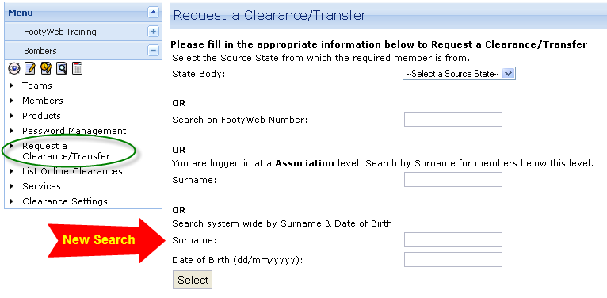

There is also a new search that allows for a search of all of Footyweb for an individual. This is designed to assist clubs to find a player when it cannot be determined which club he was last associated with.

System operation
This ‘Request a Clearance / Transfer’ link will enable clubs to commence the transfer process. Upon clicking the link clubs will need to navigate the state / league / club of the player for whom they are seeking a clearance / transfer. If the league cannot be found in the drop list of leagues it indicates that the requested players league is not using online transfers / clearances for this season and that another form of clearance is required, (see section entitled: non footyweb clearances). Clubs do not need to provide a reason for applying for a clearance but may type in additional information if they wish. Upon submission, the clearance / transfer will follow the same process as previously with the exception of the enhancements / changes outlined below.

Clearances or Transfers
These terms will be used interchangeably for the 2009 season. Once all leagues are on board with Footyweb and using online clearances / transfers, it is expected that the word clearance will be dropped all together.

Transfer List Display
This listing is available to club and league administrators at present when they log in to the administrators section of the system, this allows for clubs to view their own transfer list as well as the league their own club lists.

The listing is not yet available for public view, however is being developed and will be made available when the Competition Management module is completed and released (March/April 2009).

Transfers between leagues not using FootyWeb
For clubs/leagues who are unsure what to do when a player is transferring in or out of the VCFL/SportingPulse system and their transferring league is not using the FootyWeb system for transfers, please contact Keith Whitford 5598 3498 or 0417 340 110, who will be able to assist you with a process to follow.

Changes / Enhancements for 2009
All clearances / transfers will have three dates associated with them:
- Application date. This is the date that the clearance / transfer was first entered. Application dates will range from February 1st to June 30th (except for some Northern Territory leagues, where the transfer / clearance window is August 1st to November 30th)
- Alert Date: This is a reminder sent at 4 days from the application date for any clearance / transfer that has not been finalised. The Alert is sent via email and goes to the point in the clearance / transfer chain where the clearance / transfer is awaiting action.
- Time Limit Date: The time limit date is set upon submission of the clearance / transfer and can be seen at all levels of the clearance / transfer. The Time Limit date is set via the table below and clearances / transfers that have the time limit date applied to them will be auto-approved to the level of the ‘to league’. The Time limit date is calculated by the number of days form the application date set out in the table below where the application date is regarded as Day 0.
Time Limit Days by State
State | Time Limit Days | Refusal Reasons
Victoria | 6 Business Days | 3 defined refusal reasons only allowed
NSW | 6 Business Days | 3 defined refusal reasons only allowed
South Australia | 7 District; 14 Days State League | 3 refusal reasons, others may be permitted
Northern Territory | 7 District; 14 Days State League | 3 refusal reasons, others may be permitted
Queensland | 7 District; 14 Days State League | 3 refusal reasons, others may be permitted
Western Australia | 7 District; 14 Days State League | 3 refusal reasons, others may be permitted
Tasmania | 7 District; 14 Days State League | 3 refusal reasons, others may be permitted
All Interstate Transfers | 7 District; 14 Days State League | ‘From club’ state rules apply

Updating club and league email addresses used for clearances / transfers
All leagues on Footyweb had clearances / transfers turned on by default on February 1st. In order for clubs and leagues to receive clearance / transfer emails it is imperative that the email address used for clearances / transfers is entered at the club and league level (see screenshot below).
Please Note: Email is just a reminder of action required. Clubs should be encouraged to log in to the system frequently to check what actions they may need to perform. Not receiving an email reminder will not be permissible as an excuse for not processing a clearance or requiring an extension of time.

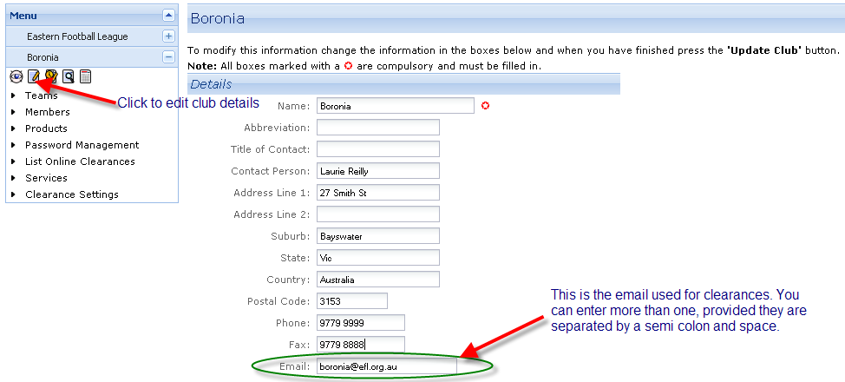

Temporary Clearances / Transfers (Permits)
Permits will now be processed in the exact same way as clearances / transfers. The only difference between the two is that permits will have a to and from date. At the expiry of the ‘to’ date the player will automatically revert back to the original ‘from’ club in the permit. The NTFL have agreed that this should be the method used for all of the clearances to and from their league where the player is intending to continue playing with his original club whether based in Darwin or elsewhere.

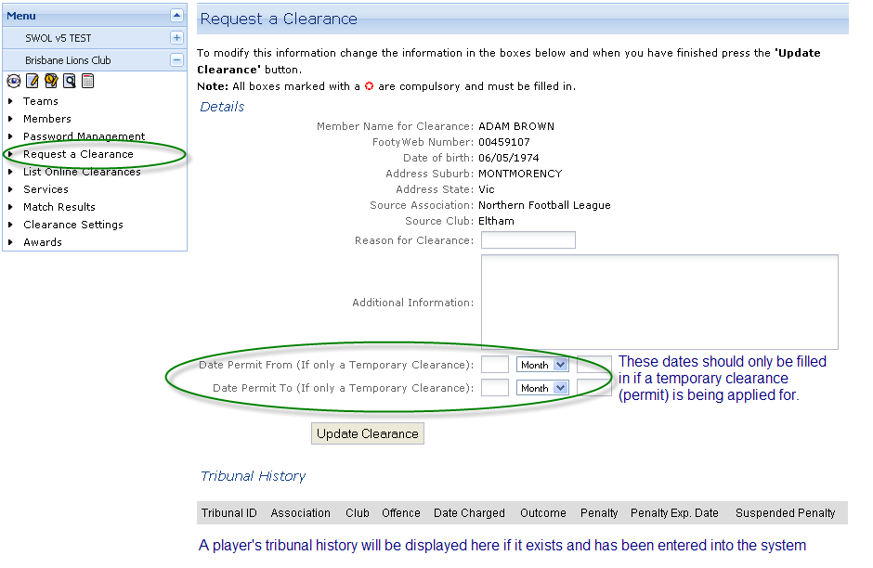
Automatic clearance approval for ‘to’ club
A new setting allows leagues to set to automatic approval clearances / transfers for the ‘to’ club. Previously these required the ‘to’ club to go in and approve even though they were the instigators of the clearance.

Tribunal
The tribunal record of players involved in clearances / transfers will be visible at all levels within the system, (see screenshot above).

Transfers for suspended players
The system does not prevent the ‘request for clearance’ for suspended players, however, it prevents the finalisation of the clearance until the suspension is served. In essence all of the same processes apply as other transfers / clearances, including time limit applications, however, the ‘to’ league will not be able to approve the clearance until the suspension is served.

Players under suspension can be permitted (temporary transfer) to other clubs. Whilst their suspension information will be visible to the new club and league the permit can proceed. It seems that this is something of a grey area, however, the general consensus is that the player must serve the suspension in the league in which he received it. In practice this would mean that the suspension would be served upon the completion of the permit period.

Offline Clearances
For leagues that are not listed via ‘request a clearance’ there is an option to submit an offline or manual clearance. This option loads a form that submits to the club’s own league. Their league will then process the clearance via whatever method they wish. Leagues that use Sportzware Central would usually process via this method.

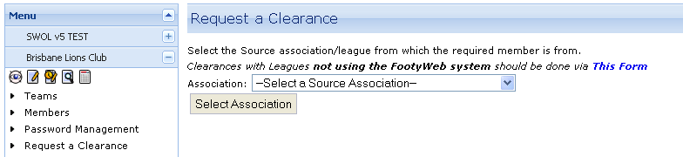

Junior Leagues - Transfer of information from Auskick

An Individuals registration information can be transferred from Auskick, provided their firstname, surname and date of birth is known. It is important to note that the individual is not taken out of the Auskick Centre just added to the new club along with all of the details that were entered when they registered for Auskick. Usually the Auskick registration data is very thorough and clubs do not need to enter additional information. It is advisable that clubs ask individuals at registration days whether they participated in Auskick. Provided that they did Auskick from 2006 onwards, their registration details should be able to be transferred.

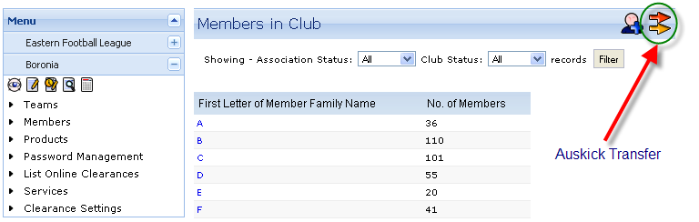

To assist with Club identification and Census data in Footyweb, could all leagues with Junior Clubs please append JFC to the Club name in Sportzware Central? Alternatively, you could ask the Clubs to do this in Sportzware Membership online.

JLT Insurance Registration – Australian Football National Risk Protection Program
Clubs and Leagues are requested to complete the above registration.

Please visit the VCFL website (Administration Section) or visit the following link http://www.jltsport.com.au/afl/

VCFL Affiliation Agreement
Clubs and Leagues are requested to complete the above agreement.

Please visit the VCFL website (Administration Section) or visit the following link http://www.vcfl.com.au/index.php?id=86

