“Back-To” 2003
KALKEE FOOTBALL CLUB
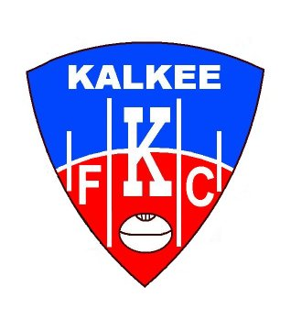
BEST OF 1990 - 2003

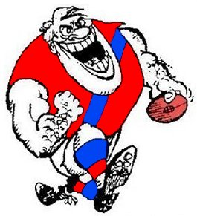

Jason Merlo David Richardson Simon Arbuckle
BACK LINE

Rod Lawson Peter McFarlane John Goldsmith
HALF BACK LINE

Simon Coleman Shayne Breuer Brett Brain
CENTRE LINE

John Pidgeon Anthony Perkins Bruce Hartigan
HALF FORWARD LINE

Simon W. Adams Ash Miller Steve Schultz
FORWARD LINE

RUCKS : INTERCHANGE :

Dean Johns Allan J. Mills

Guy Smith COACH : Brett Doolan

ROVER : Scott Batchelor Phil Mills

Scott Batchelor Mark Jasper

