MEMORANDUM

To: | WorkSafe VCFL Leagues
cc | WorkSafe VCFL Area Managers; WorkSafe VCFL Rules Committee; AFL Victoria Development Managers; AFL Victoria Coaching Development Manager
From: | Brett Connell – Operations Manager
Subject: | WorkSafe VCFL Coach Accreditation Policy
Date: | March 20, 2008

VCFL Coach Accreditation Policy

Aim: to have the best available coaches skilled in all areas of coaching to an appropriate level in control of all WorkSafe VCFL teams, with the goal of improving the standard of coaching across the WorkSafe VCFL.

in developing this policy the WorkSafe VCFL wish to provide enough flexibility to allow for the task of the volunteer coach to not become onerous, while at the same time make certain VCFL Rule 16.0 Coach Accreditation is adhered to.

Implementation: in combination with AFL Victoria have all VCFL coaches who are not currently accredited, attend and obtain a relevant level of accreditation

At the commencement of the 2008 season all VCFL coaches are required to have obtained, or hold, a current Level 1 Coach Accreditation relevant to the level of the team they will be coaching.

Assistant Coaches are not required to be accredited, however are encouraged to also hold current accreditation relevant to the level of the team they will be assisting, in the instance that they are required to coach the team.

The VCFL in drafting this policy are aware that a degree of flexibility needs to exist to cater for any number of circumstances, but not limited to (coach being removed, coach re-locating, coach being ill on matchday or an indefinite period, coach unable to attend an appropriate AFL Victoria Coach Accreditation Course relevant to the level of the team the coach will be taking charge of prior to the beginning of the 2008 season etc).

In the event that coaches do not hold the appropriate level of current accreditation the VCFL has deemed it the right of leagues to i) require the coach to attend the next available course and ii) require the club that the coach will be representing to be placed on a monetary bond, to be determined by the league, and which is to be returned upon satisfactory completion of the necessary accreditation.

VCFL Leagues have the power to determine the monetary level of the bond.
The bond is not designed to be a fine, but rather a commitment by the club and coach that the said coach will complete the necessary accreditation.

WorkSafe VCFL Leagues in combination with AFL Victoria will monitor the status of all coaches within their jurisdiction.

The AFL has committed to provide the all WorkSafe VCFL Leagues with a report from the AFL National Coaches database, that will enable the tracking of all coaches coaching in their respective leagues.

The first of these lists is due during the week beginning Monday March 24 and will be distributed to leagues and Area Managers.

Previously all WorkSafe VCFL Leagues have been required to check the status of all coaches through the relevant AFL Victoria Development Manager, once the above process is implemented WorkSafe VCFL Leagues will no longer be required to check the status of coaches via AFL Victoria Development Managers.

AFL Victoria Development Managers will be the sole determinant in terms of whether a coach has satisfactorily completed the necessary requirements to be considered accredited and placed on the AFL National Coaching database.

WorkSafe VCFL Leagues are encouraged to liaise with AFL Victoria Development Managers in relation to the courses being conducted across the 2008 season, as all courses require a certain number of mandatory commitments to be met before accreditation can be granted.

Merely attending the course will not satisfy AFL Victoria standards required to grant accreditation.

Any queries relating to the above policy or its implementation should be directed to the relevant WorkSale VCFL Area Manager.

WorkSafe VCFL Rule – relating to Coach Accreditation
16.0 COACHING ACCREDITATION
(a) All coaches of VCFL clubs are required to obtain Level 1 Accreditation prior to the commencement of the 2008 season. The penalty to be imposed by leagues if coaches continue to coach having not obtained the necessary accreditation to be, loss of match points for matches won by the team whilst the unaccredited coach continues to coach, beyond a date agreed to by both the league and the club/coach. In the event of no match points being received the league may impose an appropriate penalty.
(b) All coaches of Affiliated VCFL teams up to and including U/18’s will be reimbursed $50.00 following the achievement of Level 1 accreditation. All applications for reimbursement must be made through the VCFL Area Manager.

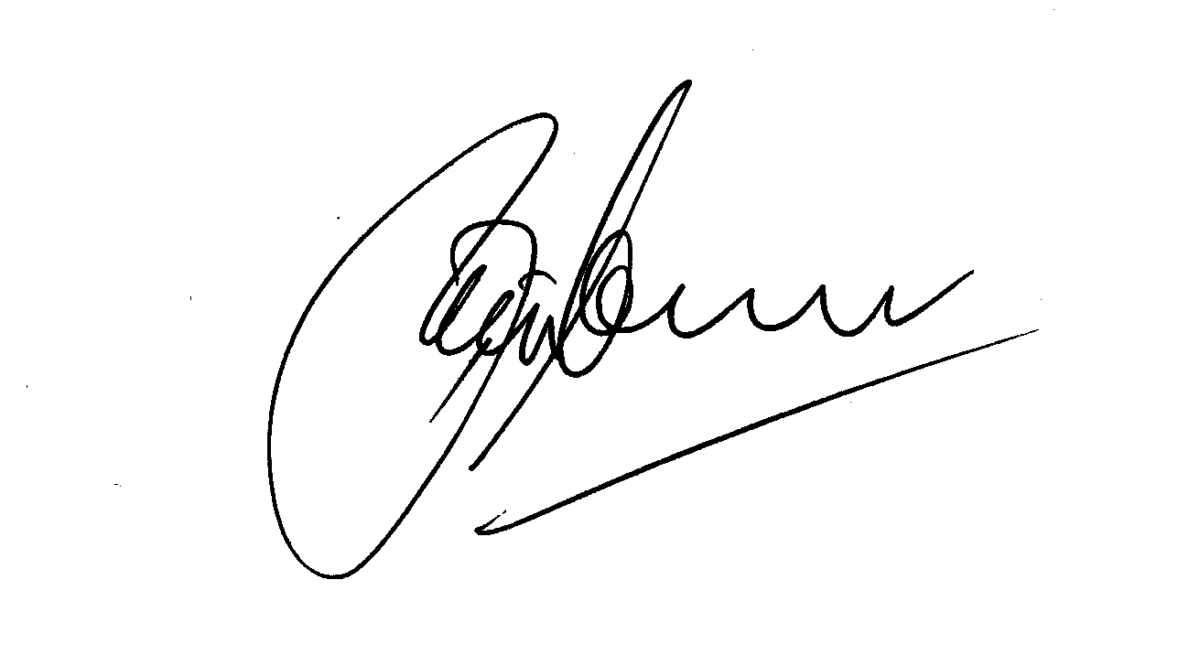
Regards,

Brett Connell
Operations Manager
WorkSafe Victorian Country Football League

