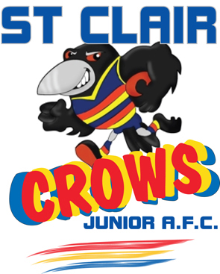
ST CLAIR JAFC “The Mighty Crows”

2013 Application to Coach

Name:

Address:

Contact No’s:

Email:

Coaching Certificate - Level ________ Card No ____________

Other Qualifications: eg Sports Trainer/1st aid _______________________________

Team applying for - 1st preference ______Age_________________

Team applying for - 2nd preference ______Age_________________

Do you have a son/daughter playing in this age group? ______________

Will you and your team support Club field duties at all times _________________________

Will you be putting in a weekly match report for your game __________________________

As coaches are appointed to General committee will you attend every club meeting _____

Outline playing and coaching experience ____________________________________________

______________________________________________________________________________________________

______________________________________________________________________________________________

My coaching philosophy is

Reason for applying for this team

In Age groups where there is more than one coach the decision of who is designated Head Coach will be made by the committee who may conduct interviews to make this decision.

The St Clair JAFC requires all coaches to be accredited with a Level One or higher certificate as issued by the AFL. The Club will cover the cost of accreditation.

If I am appointed as a coach I will abide by the GSJ code of conduct and the St Clair JAFC code of conduct and constitution. I have an expectation of not losing any players at the end of the season because they did not increase their skill and confidence levels and or did not receive equal recognition & encouragement.

……………………………. / /
Signature Date

Applications can be mailed to PO Box 121 St Clair 2759 or emailed to stclaircrows@y7mail.com

