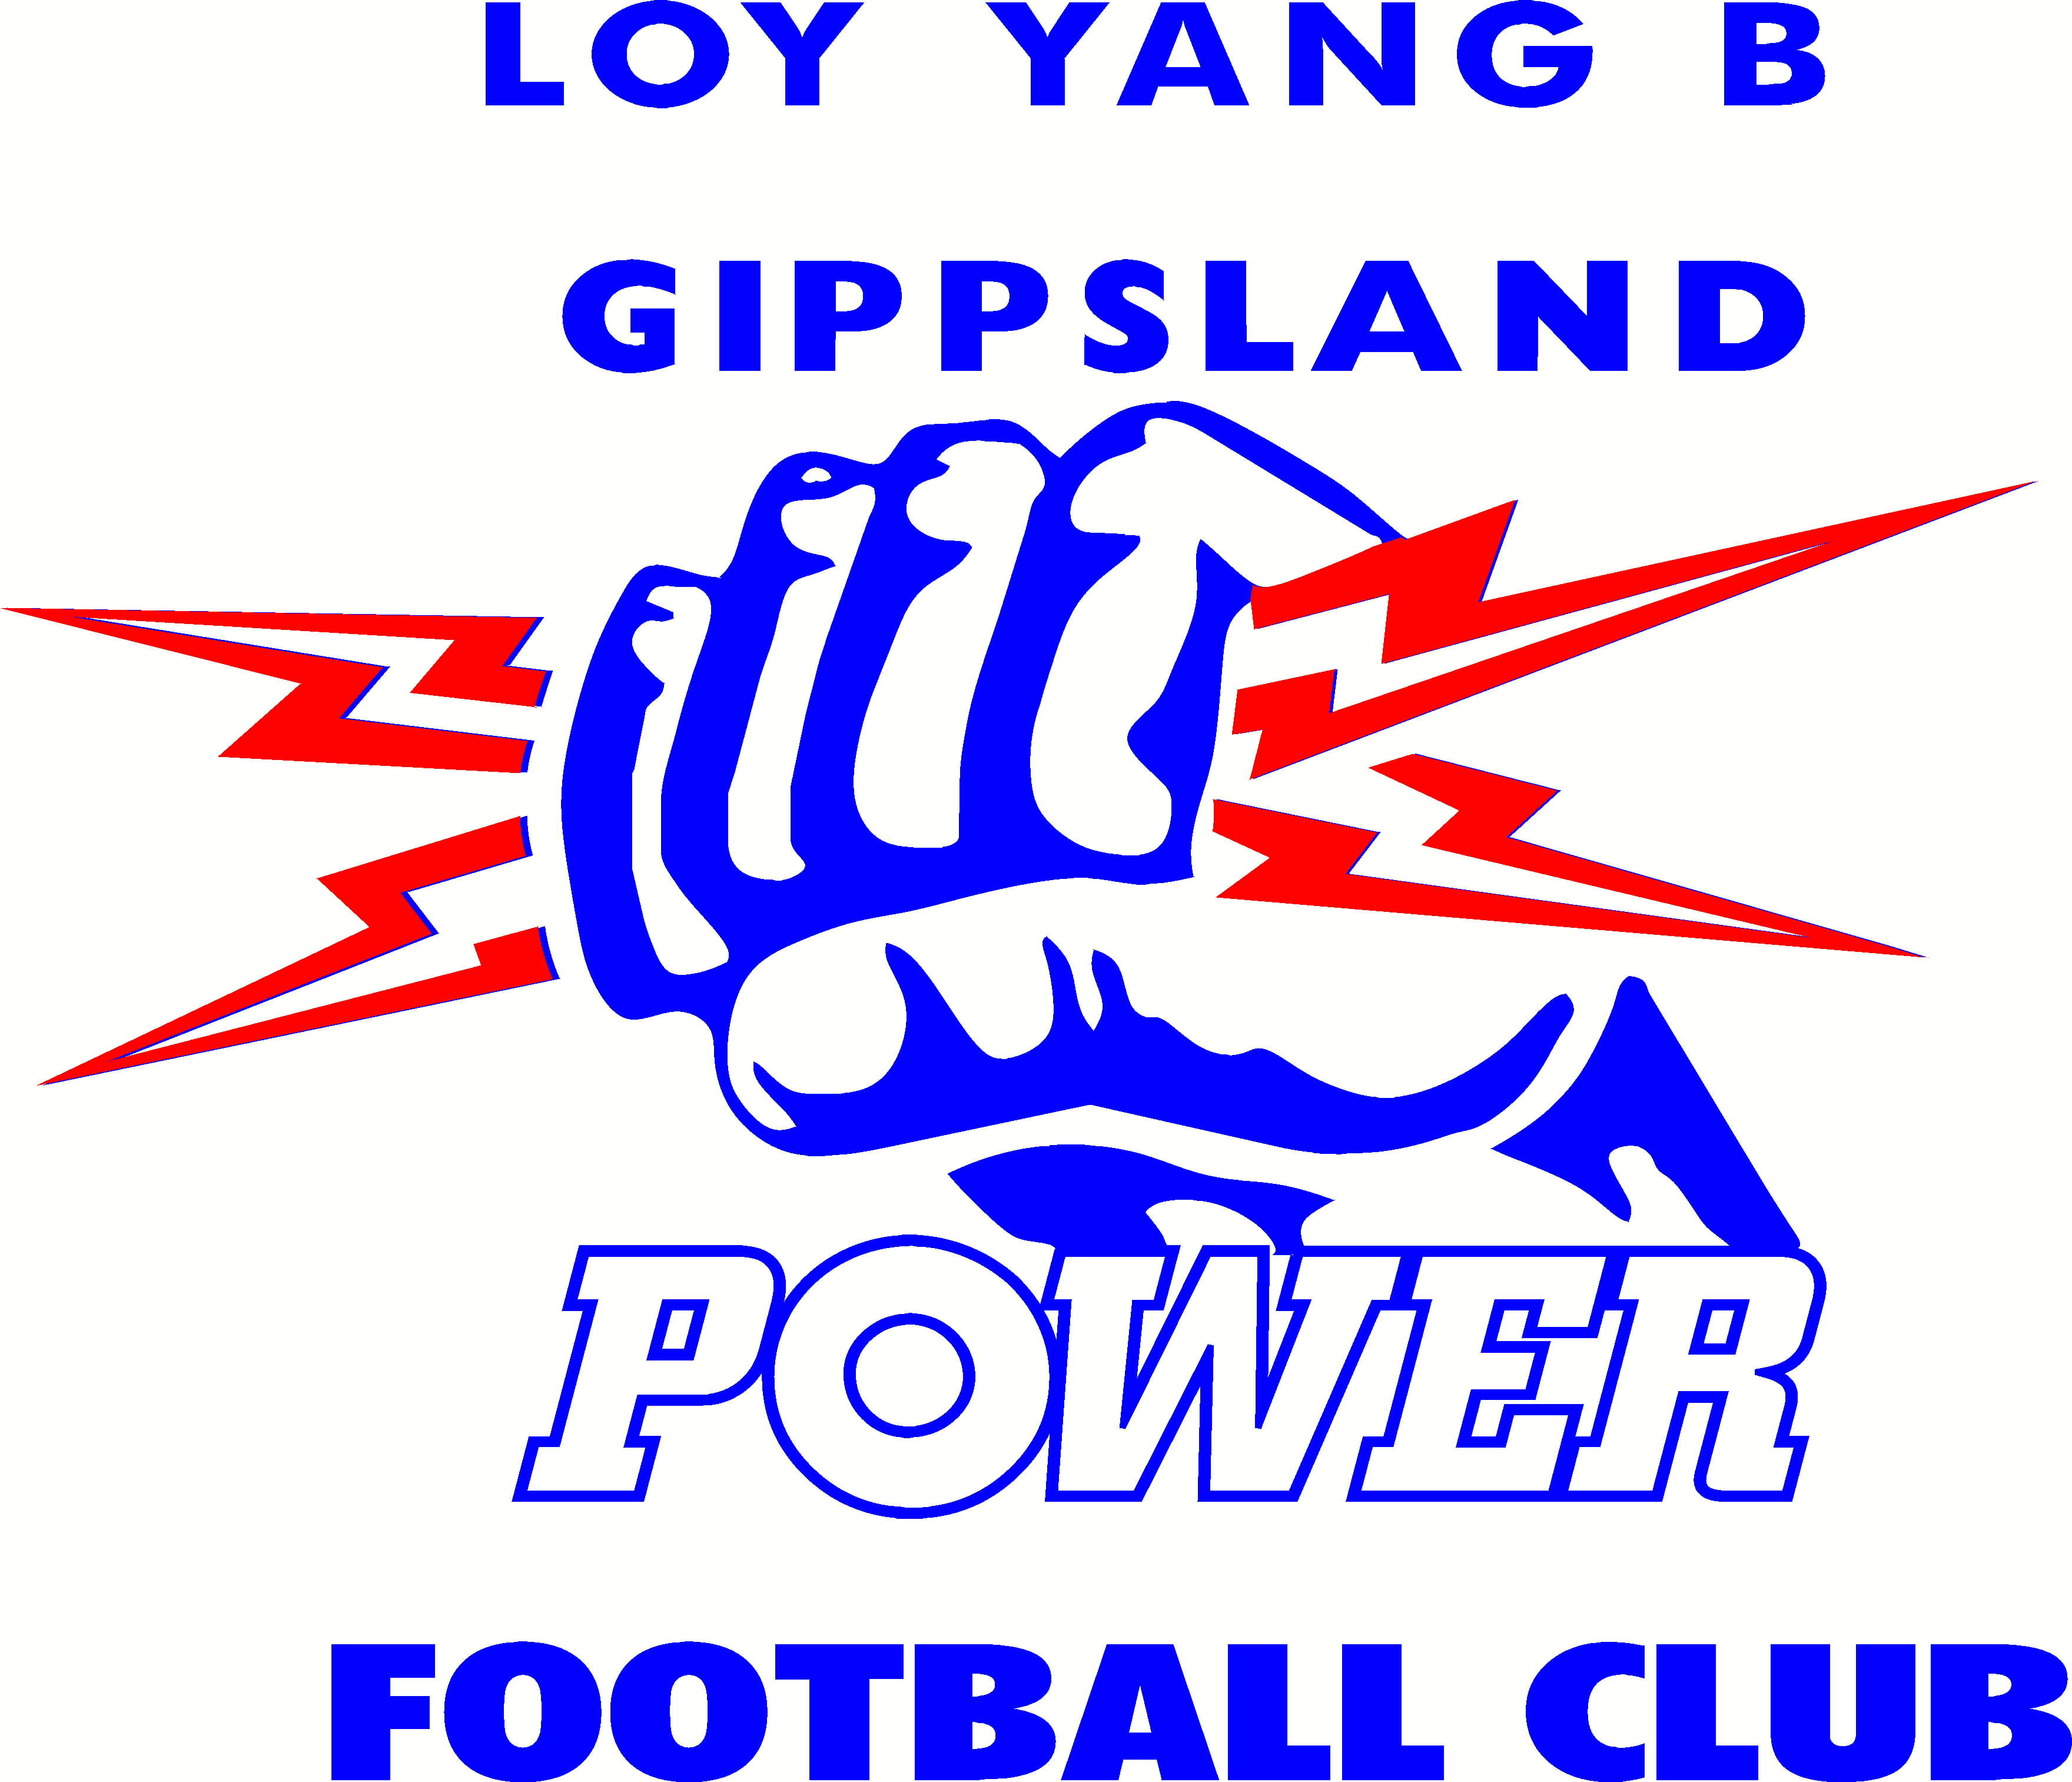

MEDIA RELEASE

Wednesday 5th November 2008

DAMIAN CARROLL JOINS GIPPSLAND POWER

The Loy Yang B Gippsland Power are pleased to announce that Damian Carroll has been appointed Under 18 TAC Cup Coach/Development Manager (full time).

Carroll played a total of 233 VFA/VFL games with the Springvale now Casey Scorpions Football Club including their 1995, 1998 and 1999 Premierships. He is also a member of the VFA/VFL 1990’s “Team of the Decade”, a club Best and Fairest in 2002 and an VFL State Representative in 1997 and 1998.

Following his retirement from the VFL in 2004, Carroll has been playing coach of Bonbeach Football Club in the Mornington Peninsula Nepean Football League for the past five seasons.

Carroll is excited about the opportunity to coach in the TAC Cup at the elite junior level.

“I’m really looking forward to the challenge” Carroll said. Having been involved with several Dandenong Stingrays youngsters at his current club Bonbeach Carroll knows what it takes to reach the highest level having tried out with Melbourne F.C. 1990, Fitzroy F.C. 1992 and St Kilda F.C. 1994.

“(The Role)” is going to be new to me, so initially I’ll be doing a lot of research watching tapes of games” Carroll said. I’m really looking forward to the excitement of getting out there and working closely with the boys at training, and helping them reach their goals and dreams.

Carroll will start full-time in December with Power and will attend the Player Parent information day on Sunday 9th November at Lowanna College, Newborough.

