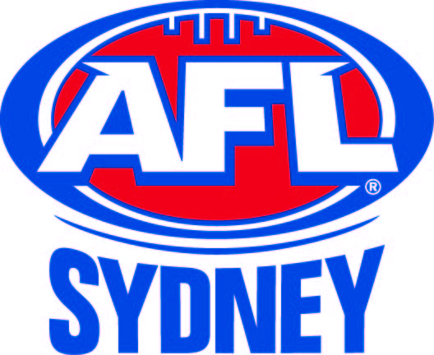
AFL Sydney Premier Division Teams

QUALIFYING FINAL
NORTH SHORE vs PENNANT HILLS
@ Henson Park – Saturday @ 3.15pm

NORTH SHORE
B: M. Thomas, R. Pryor, J. O'Dell
HB: R. Lynch, R. Wason, L. Kilpatrick
C: A. Harry, L. Pryor, J. Weir
HF: N. Todd, C. Murphy, T. Schmidt
F: P. Codling, P. Brackin, J. Davis
R: S. Naismith, D. Fitzgerald, B. Fitzgerald
Int: Z. Manley, D. Hadden, S. Carruthers, J. Harry
Emg: B. Barnes, C. Callander, T. McMahon

In: J. O'Dell, J. Weir, N. Todd
Out: D. Schacher, C.Callender, T.McMahon

PENNANT HILLS
B: C. Smith, M. McCamey, S. Parker
HB: K. Wright, T. Widmer, D. Dell'Aquila
C: M. Crawford, T. Wales, J. Barty
HF: B. Jack, D. Witt, N. Campbell
F: R. Watts, L. Bilbe, M. Carey
R: S. Widmer, B. Jack, A. Goodall
Int: H. Angel, T. Edmonds, A. Nixon, P. Barnes
Emg: M. Baglin

In: M. Crawford, A. Nixon, R. Watts
Out: A. Crisfield, S. Wray, A. Richardson

ELIMINATION FINAL
BALMAIN vs ST GEORGE
@ Blacktown International Sportspark – Sunday @ 3.15pm

BALMAIN
B: D. Brian, S. Lee-Steere, J. Farrell
HB: J. Fretwell, C. Bolt, T. Stevens
C: L. Conway, J. Monk, T. Matson
HF: C. White, K. Pearson, J. Cass
F: A. Cottrell, B. Taggart, A. Hill
R: T. Luff, M. Round, G. Wilkie
Int: A. Azhar, W. Blackburne, T. Mabon, K. Ericson
Emg: K. Jones, J. Maniscalco, S. Bowen

In: K. Ericson, A. Hill, T. Luff, B. Taggart, J. Cass
Out: G. King, S. Wallwork, K.Jones. J.Maniscalco, S.Bowen

ST GEORGE
B: D. Rixon, M. Milner, M. Graham
HB: R. Bennett, P. Sain, B. Sharp
C: D. Lycakis, D. Ryan, L. Perris
HF: B. Addison, N. Ryan, D. Donohue
F: J. West, J. Saddington, L. Broome
R: P. McBride, B. Guthrie, S. Wilsen
Int: B. Jones, R. Bajada, A. Wynn, N. Kenny
Emg: B. Voigt, T. Addison, D. Napper

In: L. Broome, R. Bajada, D. Lycakis, M. Graham
Out: D. Gilbert, B.Voigt, D.Napper

AFL SYDNEY WOMEN’S GRAND FINAL
BALMAIN vs SYDNEY UNIVERSITY
@ Henson Park – Saturday @ 1.10pm

BALMAIN
B: G.Barton, K.Kobzan, A.Rodger
HB: D.Pye, N.Spangher, K.Spilarewicz
C: E.Cordina, K.Fitzsimmons, G.Johnston
HF :O.Hall, C.McDonald, A.Kelly
F: A.Christy, B.Pride, L.Holdsworth
R:: H.Warren, E.Davison, J.Buckthought
I/C: J.Thorpe, L.McGinnigle, S.Moore, R.Morgan, A.Parkin, L.Rowan
Emg: J.Bradley, E.Brooks,S.Thomson

SYDNEY UNIVERSITY
B: A.Garland, M.Gray, A.Leonard
HB: B.Watts, J.Lew, K.Winkley
C: A.Morgan, K.Lancaster, N.Vrachnas
HF: M.Morriss, T.Lenon, M.Nguyen
F: B.Michalk, L.Sadler, A.Roberts
R: L.Creber, C.Mallon, U.McKay
Int: K.Byrne, S.Clarke, A.Engel, J.Hogan, S.Jantejovic, V.Pye

