Roy Cazaly

St.Kilda / South Melbourne / City / Preston / North Hobart / New Town / Camberwell / Hawthorn

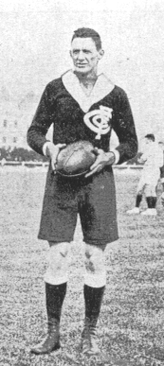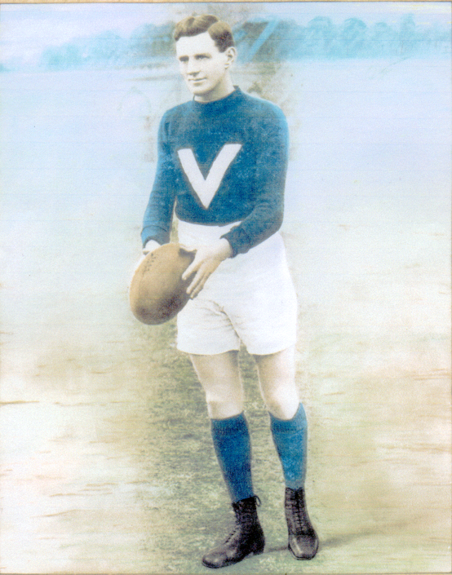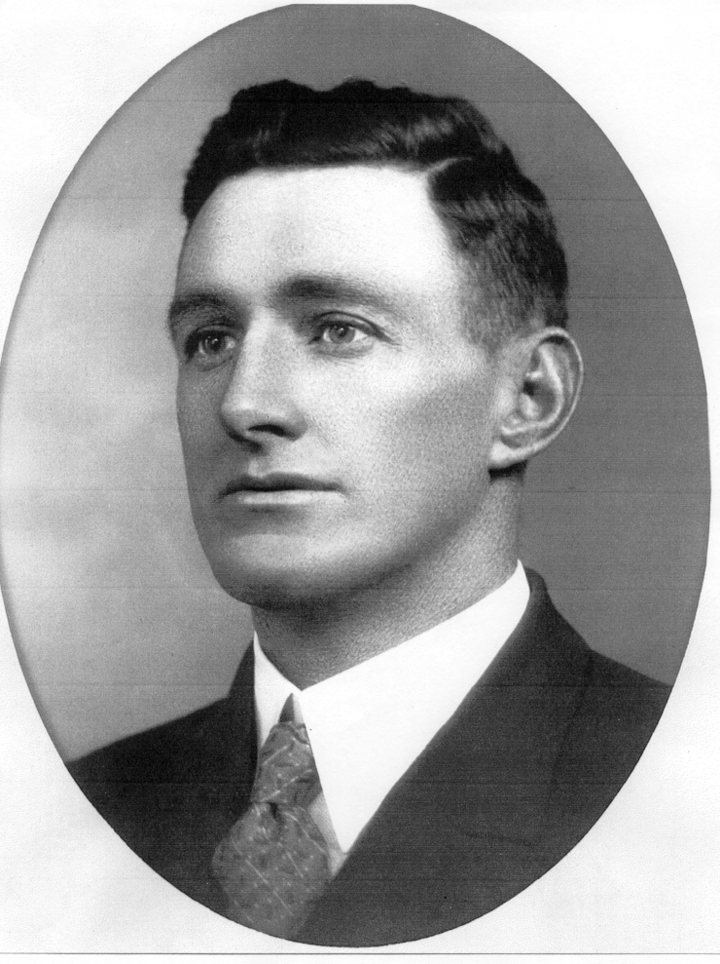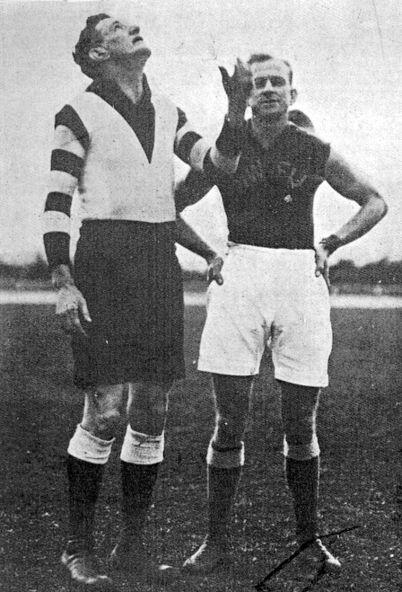

Roy Cazaly's name - used as a battle cry by Australian troops during the second World War - is almost synonymous with the sport of Australian football.

It is somewhat ironic therefore that as a player he was remembered for his time at St.Kilda (where he played 99 games between 1911 and 1920) as "just another footballer" (although the fact that he was voted Champion of the Colony, a pre-cursor to the Brownlow Medal, in 1920 appears to give the lie to this somewhat), only eking out a reputation as a 'superstar' when he joined South Melbourne in 1921.

While at South he added another 99 senior games, made his Big V debut (going on to play 13 times), topped the club goalkicking list on two occasions, and won the best and fairest award in 1926. Less tangibly, he established a reputation as Victorian football's foremost aerialist, giving rise to the time-honoured catch cry - first coined by team mate Fred Fleiter - 'Up there Cazaly!'
Cazaly was more than just a brilliant aerialist, however. A non-smoking teetotaller, he was ahead of his time as far as fitness went, and he combined superb physical conditioning with an acute football brain. The former enabled him to play and coach well over 400 senior games in Victoria and Tasmania, while the latter was on eminent display during a highly successful 7 premiership coaching career.
While Roy Cazaly played at various levels over five decades, including around 25 years at elite level, 18 state games for both Victoria and Tasmania and 198 VFL games, it was as a coach that he made the greatest impact in Tasmanian football.

His coaching career started in 1918 with Camberwell Juniors and finished in 1951 with New Town and included City, North Hobart and New Town in Tasmania and Camberwell, Preston, Hawthorn and South Melbourne in Victoria.

Some of the highlights of his coaching in Tasmania include:

- Leading Launceston based City Football Club to 2 regional and 2 state premierships and re-establishing Northern Tasmanian football as a force in the State.

- Discovering a young Laurie Nash who made his debut in senior football under Cazaly’s coaching at City.

- Led New Town to their first senior Tasmanian premiership in 1935 and then again in a ‘golden era’ post war when they won 3 regional and 1 state premiership.

Arguably one of his most famous coaching achievements occurred while at Hawthorn during World War Two. The Club was known until that time as the ‘Mayblooms’ and he ensured that they adopted the more fearsome ‘Hawks’ nickname and thus the scourge of many VFL / AFL teams in the latter half of the 20th century was christened.

The most durable and successful coach in the history of Tasmanian senior football passed away in Hobart on October 10th 1963.

In June 2004, Roy Cazaly was named at the coach in the official Tasmanian 'Team of the Century'.

He was inducted as an inaugural ‘Legend’ of Tasmanian football in 2005 and is duly elevated as the 6th Icon of the Tasmanian game in 2007.

- City (NTFA) premierships, 1928 & 1930.
- North Hobart premiership, 1932.
- New Town premierships, 1935, 1948, 1949 & 1951.
- State Premierships, 1928, 1930, 1948.
- Coached NTFA combined team, 1928, 1929 & 1930.
- Coached Tasmanian State team, 1954.
- Named as assistant coach of North Hobart’s Team of the Century.
- Named coach of the Tasmanian Team of the Century.

